Pure Components ->

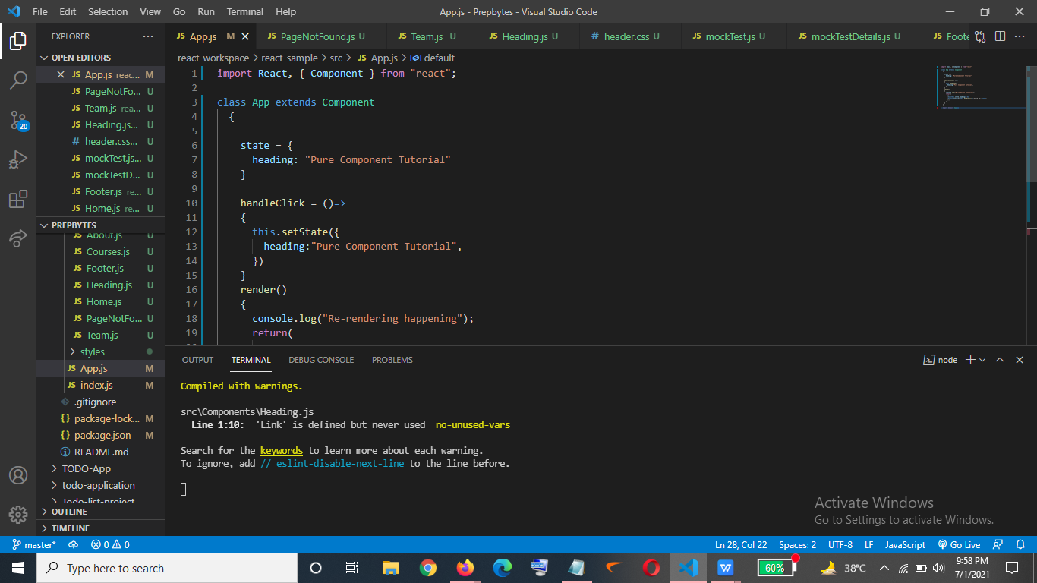

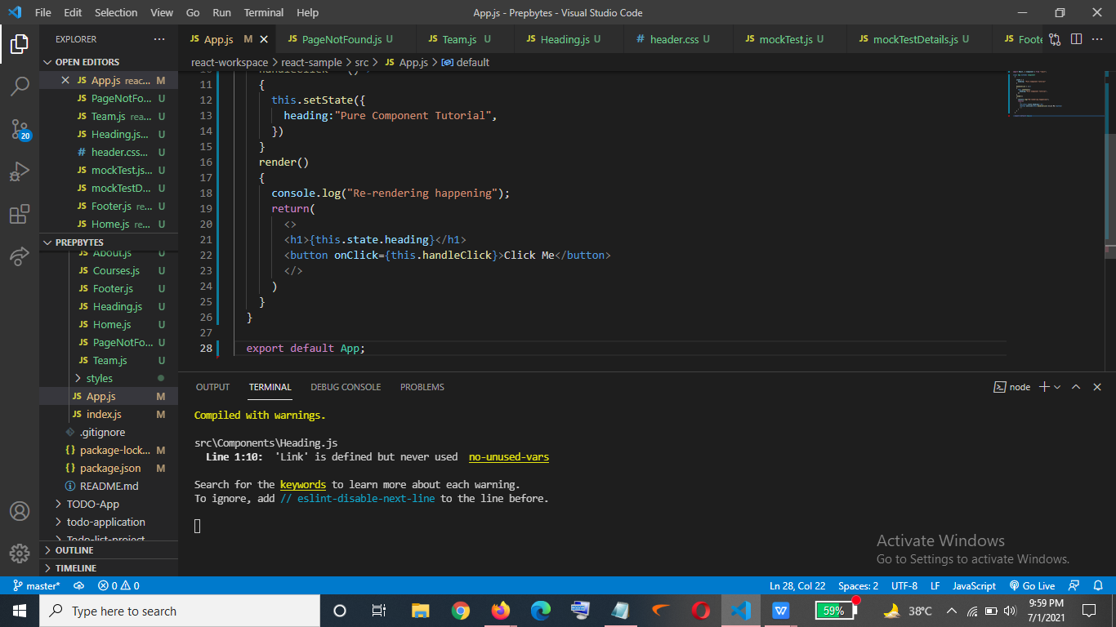

Output->

If I will click on the button for suppose n number of times and still there is no change happening but still the re-rendering happens as can be seen below->

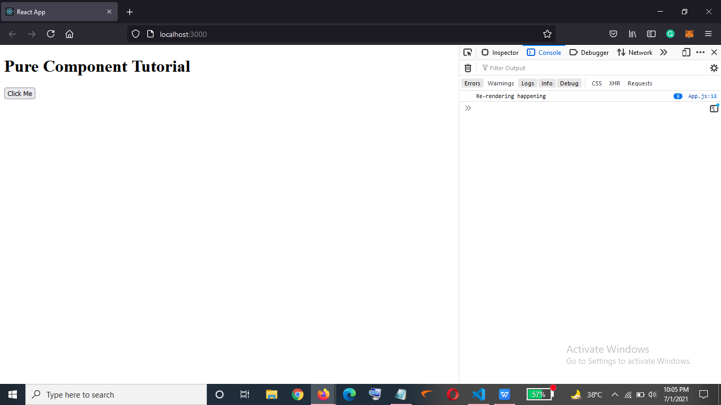

To avoid this we extend ‘Pure Component’

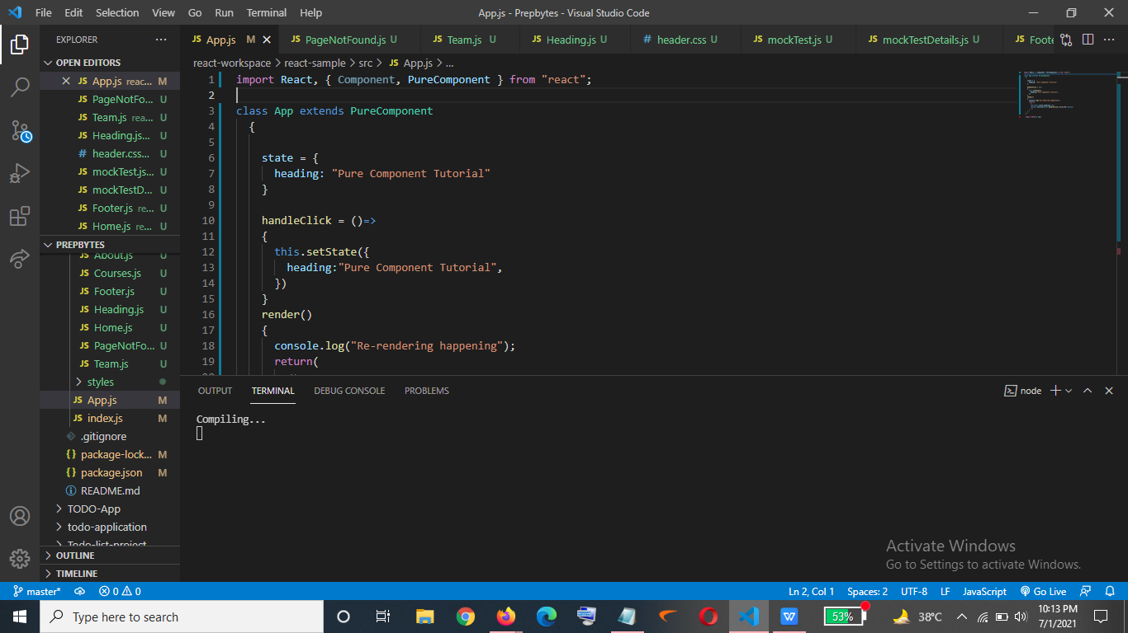

Output->

No matter how many times I click on the button it won’t re-render it again and again.

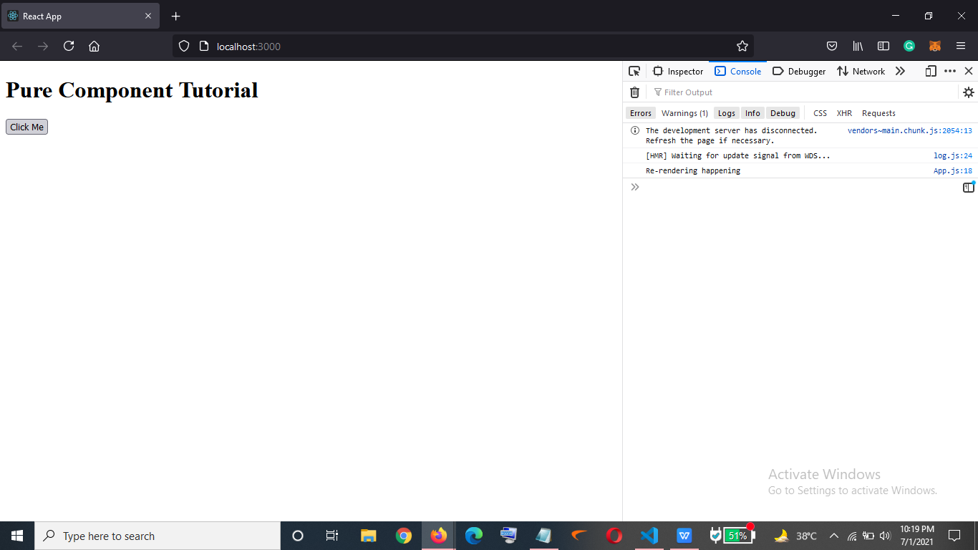

What if we want the text of the button to be changed once clicked->

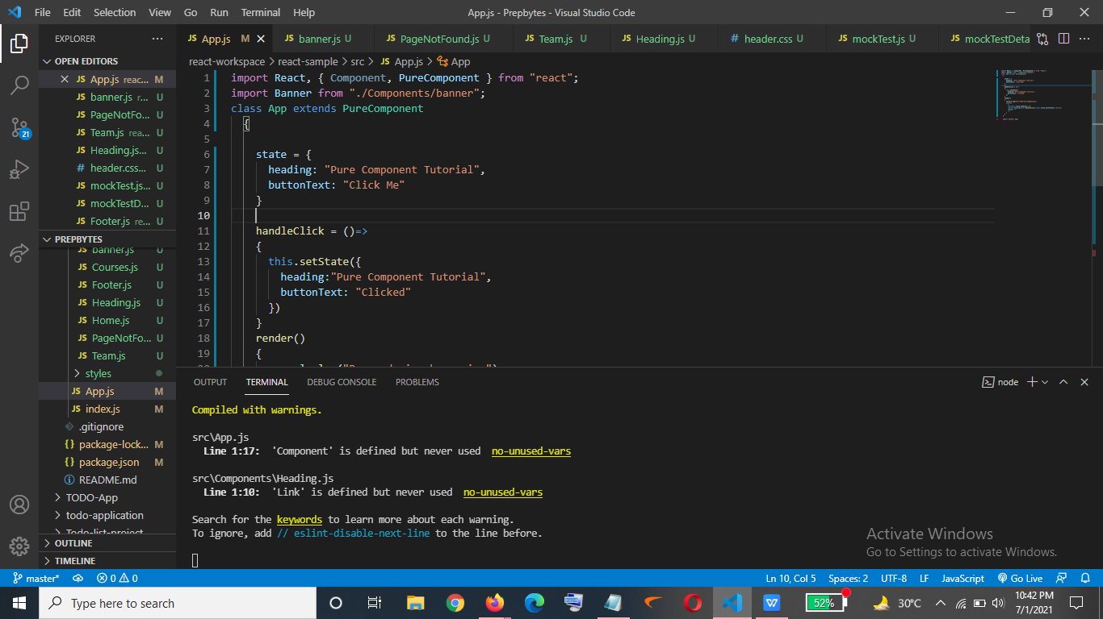

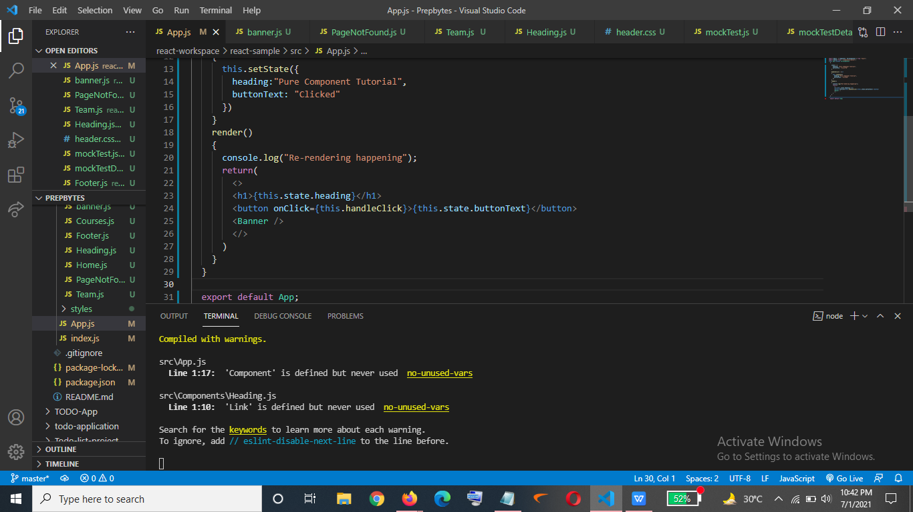

Output->

Before clicking on the button-

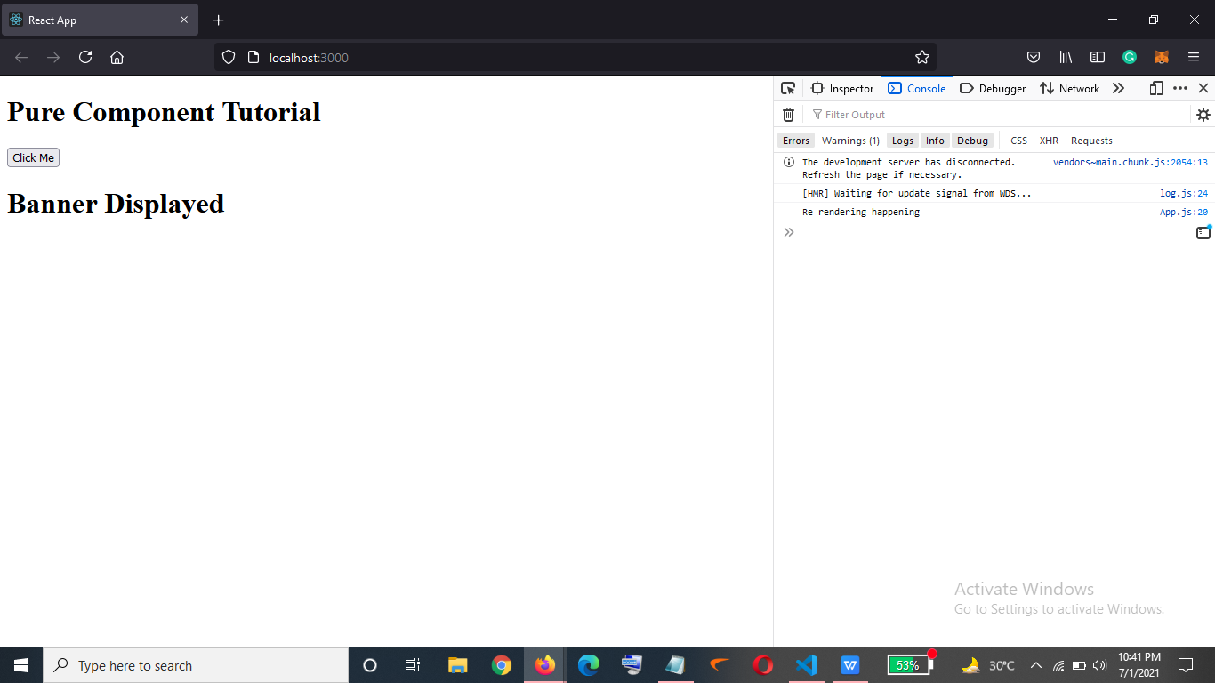

After Clicking on the button - >

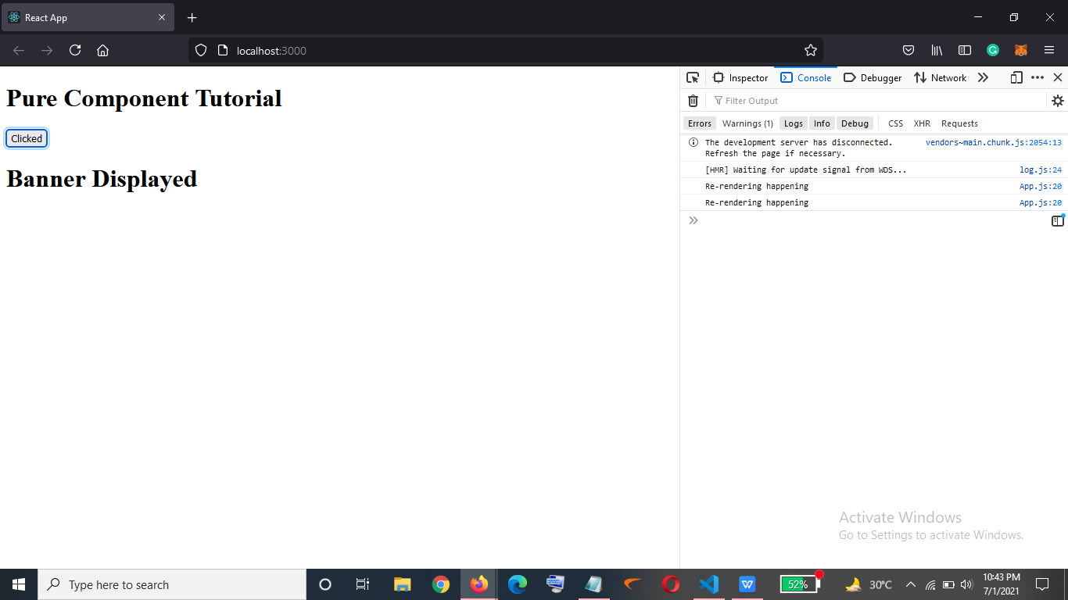

Now we will use Pure Component using props->

Banner.js ->

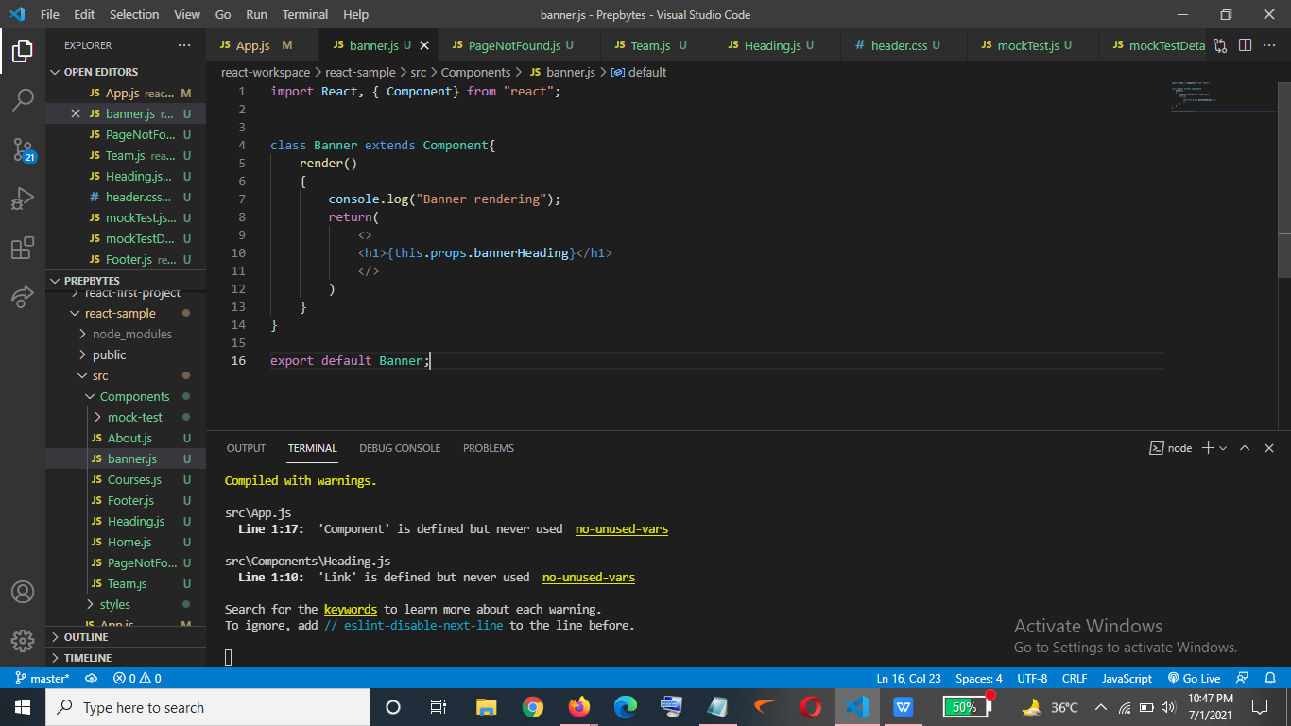

App.js

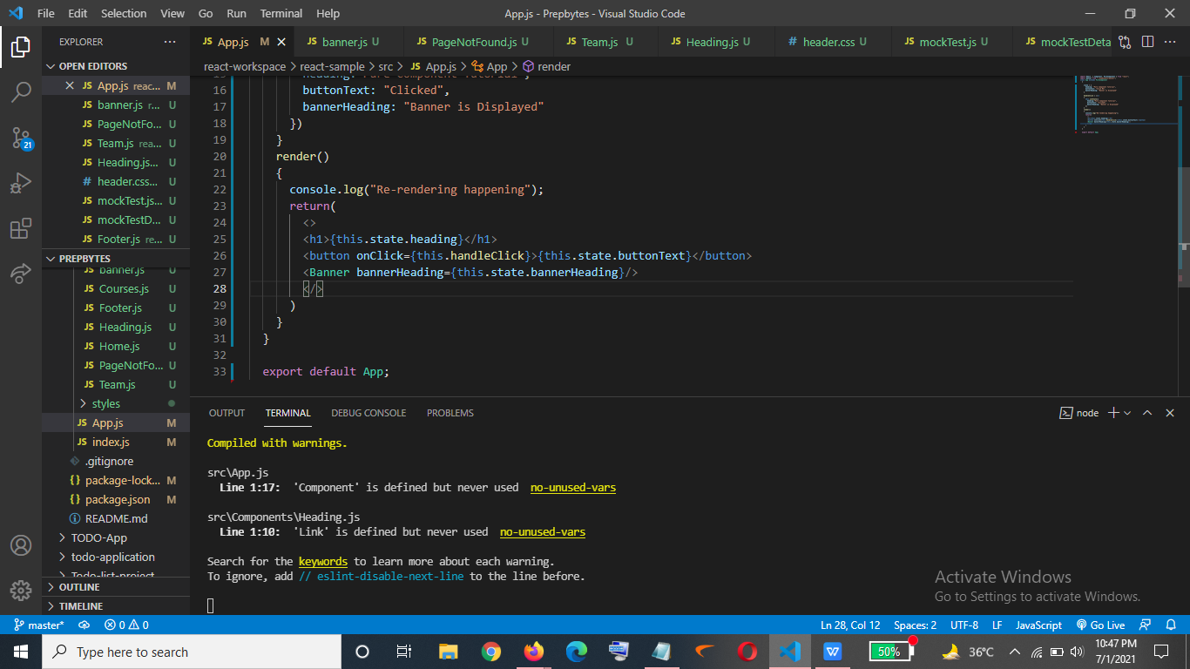

Output->

When I click on button the banner heading is also rendered which I don’t want

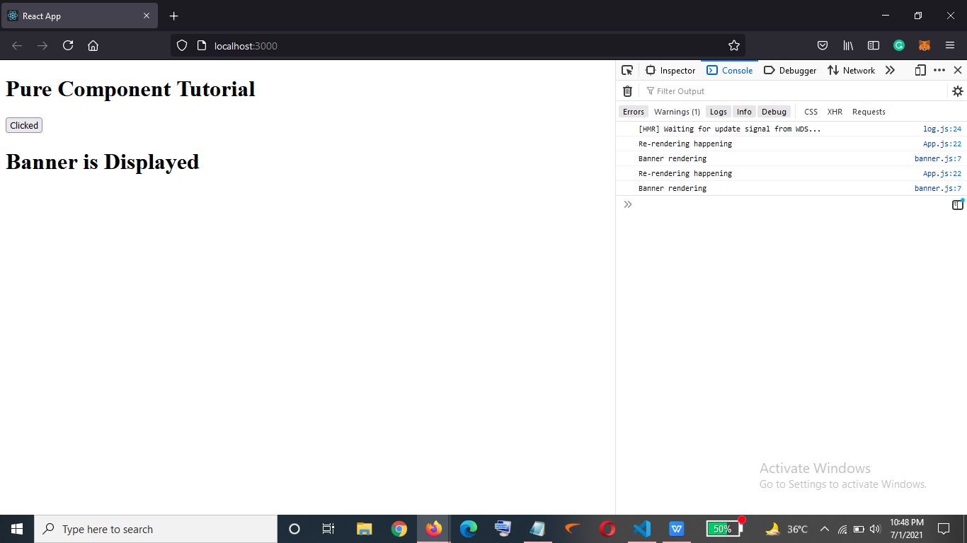

To avoid this ->

We will now extend the PureComponent in banner.js file as well->

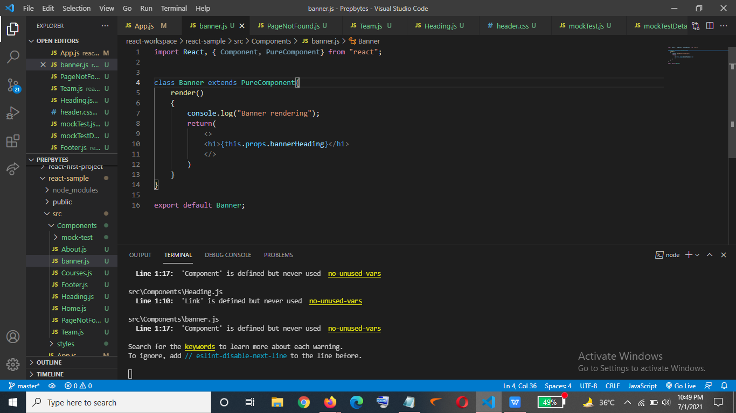

Output->

So after I click on the button as now we can see below that the rendering for banner is not there

